Cabinet Water Stills
The WSC ranges are a smart and easy way of distilling water. All are thermostatically controlled shut off (Electrics only)
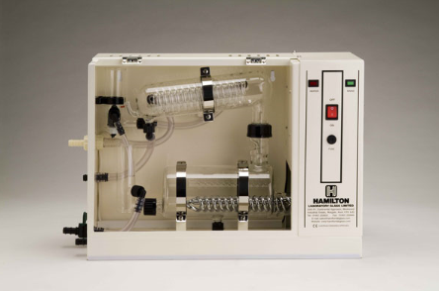
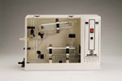 | 4 litre/hour Cabinet Stills  WSC/4 - fitted with metal heater  Price £1132.00 (ex VAT and ex Delivery)
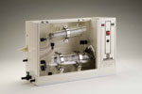 | 4 litre/hour Cabinet Stills  WSC/4s - fitted with silica heater  Price £1223.00 (ex VAT and ex Delivery)
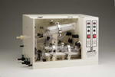 | Double Distillation Cabinet Stills  WSC/4D - Output approximately 4 litres per hour of high purity distillate. 4 silica heaters

WSC/8 and WSC/8s - fitted with metal and silica heater are also available.
Please note: A range of fully automatic water stills, please contact your local Lab Chemicals Sales Office for further details.

